AIDCORE

AI Driven Customer Operations

&

Realtime Engagement

**Author**: IISc Group-7

**Version**: 0.5

**Date**: 26-May-2024

**Table of Contents**

1. Project Title 2

2. Brief problem statement 3

3. Background information: Include domain information, problem description and analysis, possible applications 3

4. Motivation for selection of the project 4

5. Detailed dataset description and dataset source 4

6. Current benchmark: provide references (if any) 4

7. Proposed Plan: 5

a. Define the methodology, including: 5

b. Approaches 5

c. Packages and tools 5

d. Algorithms 5

e. Metrics 5

f. Outline the stages with defined deliverables. 5

8. Develop a deployment plan, considering options like Gradio, Streamlit, FastAPI Spaces etc. 5

9. Implement MLOps tools for effective management and automation. 5

10. Preliminary Exploratory Data Analysis 5

11. Expected outcomes 5

12. Project demonstration strategy (tentative plans) 5

13. Proposed timeline of project stage executions (eg. Gantt chart): Include 5

14. weekly progress goals for each of the 4 Capstone Project Mentored Sessions. 5

15. Team members’ names 6

16. Designated team coordinator's name(s) 6

# 

# **Project Title**

AIDCORE: AI Driven Customer Operations & Realtime Engagement

# **Brief problem statement**

# Businesses in the ecommerce space struggle with accurately understanding customer sentiment, gaining detailed product performance insights, and effectively benchmarking against competitors. Additionally, they face challenges in real-time customer engagement by proactively reaching out to the customers to address their needs or inform them latest products updates. User feedback is often underutilized, leading to missed opportunities for improvement. AIDCORE aims to address these issues by leveraging AI to analyse user feedback, enhance customer understanding, engagement, and satisfaction, and drive continuous product improvement.

# **Background information: Include domain information, problem description and analysis, possible applications**

In the rapidly evolving ecommerce landscape, businesses face significant challenges in understanding and responding to dynamic customer needs and preferences. Traditional methods of customer engagement and product performance analysis are often insufficient, leading to missed opportunities for enhancing customer satisfaction and loyalty. Key issues include:

**Inefficient Sentiment Analysis:** Companies struggle to accurately gauge overall customer sentiment and its evolution over time, hindering their ability to promptly address dissatisfaction.

**Limited Product Performance Insights:** There is a lack of comprehensive, aspect-specific performance data, including feature satisfaction, quality perception, and common problems, which impedes the ability to improve products effectively.

**Competitive Benchmarking:** Businesses find it challenging to conduct detailed comparisons of their brands, categories, and SKUs against competitors, making it difficult to identify areas for improvement and differentiation.

**Media and Market Understanding:** Companies often lack the capability to continuously monitor and interpret changes in the ecommerce space, customer behaviour, and brand focus areas, leading to outdated strategies.

**Reactive Customer Outreach:** Current systems for real-time customer engagement and recommendations are underdeveloped, resulting in delayed responses to customer needs and feedback.

**Lack of Proactive Issue Resolution:** Businesses frequently fail to proactively address critical reviews and retain customers through trust-building and need-based recommendations.

**Dynamic Advertising Challenges:** There is a need for more effective use of dynamic advertisements to improve brand image, inform customers about new features, and engage them with compelling content.

AIDCORE aims to address these challenges by leveraging advanced AI technologies to provide a holistic and responsive customer engagement platform. This platform will enable businesses to understand customer sentiment, analyse product performance, conduct competitive benchmarking, stay updated with market trends, and execute both reactive and proactive outreach strategies effectively.

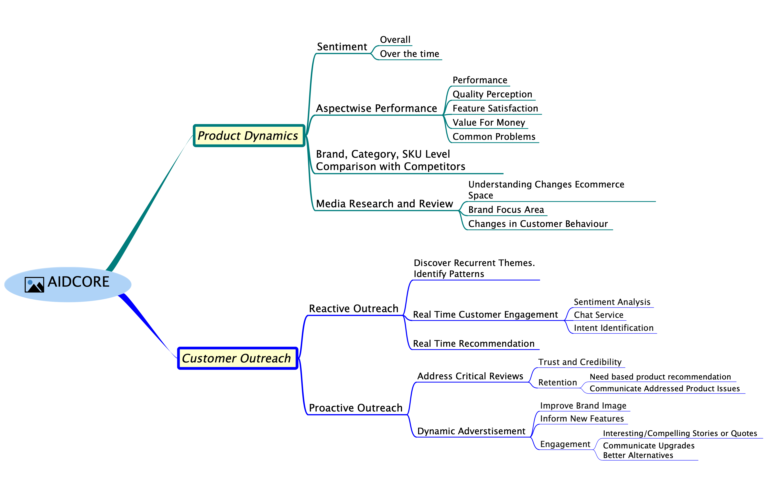

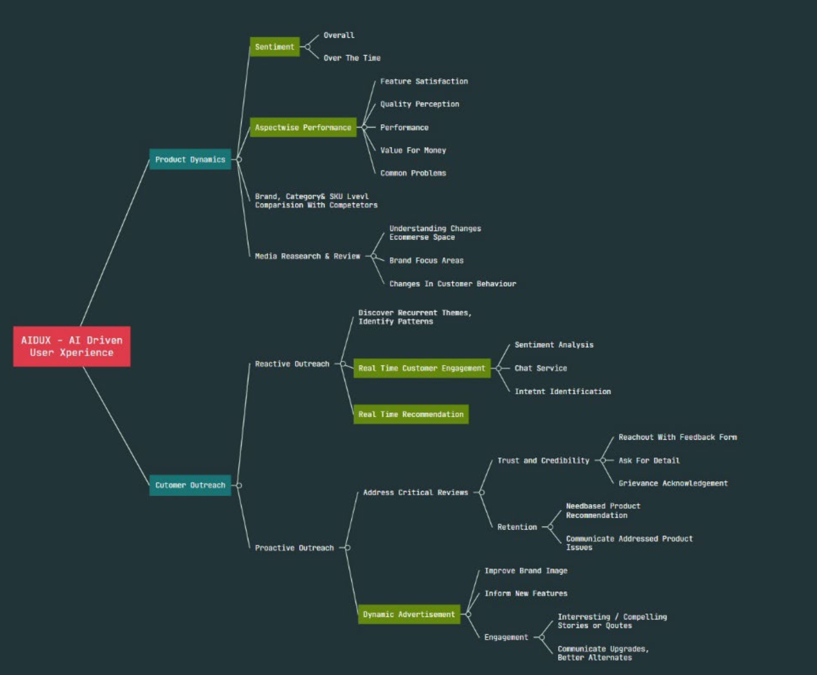

# **Motivation for selection of the project**

# Enhancing customer understanding and satisfaction leads to increased loyalty and repeat business. By leveraging AI to analyse user feedback, businesses can gain invaluable insights into customer preferences, pain points, and desires, enabling them to tailor their products and services to better meet customer needs. This not only fosters stronger customer relationships but also drives higher customer lifetime value and revenue growth.

# **Detailed dataset description and dataset source**

* 1. <https://www.kaggle.com/datasets/bittlingmayer/amazonreviews>
  2. <https://nijianmo.github.io/amazon/>
  3. <https://huggingface.co/datasets/amazon_us_reviews>
  4. **From TS team:**
     1. <https://www.kaggle.com/datasets/veeralakrishna/relational-strategies-in-customer-servicersics>
     2. <https://www.kaggle.com/datasets/kreeshrajani/3k-conversations-dataset-for-chatbot>
     3. <https://www.kaggle.com/datasets/thoughtvector/customer-support-on-twitter>
  5. If required, we will scrape from web

# **Current benchmark: provide references (if any)**

* 1. <https://www.meetyogi.com/>
  2. [www.amazon.com](http://www.amazon.com)

# **Proposed Plan:**

## **Define the methodology, including:**

To solve the problems outlined in the ecommerce space using user feedback, several statistical and AI methods can be employed. Here are some of the key methods:

**Sentiment Analysis:** This involves using Natural Language Processing (NLP) techniques to analyse the sentiment expressed in user feedback. Methods such as Bag-of-Words, Word Embeddings (e.g., Word2Vec, GloVe), and Transformer-based models (e.g., BERT, GPT) can be utilized to understand the sentiment polarity (positive, negative, neutral) and the intensity of emotions expressed in the feedback.

**Topic Modelling:** Topic modelling techniques such as Latent Dirichlet Allocation (LDA) and Non-Negative Matrix Factorization (NMF) can be employed to identify the main topics or themes present in user feedback. This helps in understanding the key issues or concerns raised by customers and categorizing feedback into relevant topics for further analysis.

**Aspect-Based Sentiment Analysis:** This involves identifying specific aspects or features of products/services mentioned in user feedback and analysing the sentiment associated with each aspect. Techniques such as Aspect-Based Sentiment Analysis (ABSA) and Named Entity Recognition (NER) combined with sentiment analysis can help in extracting and analysing aspect-level sentiment from user feedback.

**Deep Learning Models**: Deep learning models like pretrained Transformer-based models (BERT, Dynamic Multi Class Classification Model), can be trained on large datasets of user feedback to automatically extract meaningful patterns and insights. These models can be used for tasks such as sentiment analysis, topic modelling, and entity recognition.

**Reinforcement Learning (RL):** LLM agents can learn to make optimal decisions (e.g., which responses to send to customers, when to offer discounts or promotions) based on past interactions and feedback received from customers. Also RAG can be used.

**Collaborative Filtering**: Collaborative filtering techniques, such as Matrix Factorization and Neural Collaborative Filtering, can be used to make personalized recommendations to customers based on their past interactions and feedback. These techniques help in improving customer engagement and satisfaction by offering relevant products or content tailored to individual preferences.

**Competitive Analysis**: We can track the user sentiment over the and compare it competitors’ sentiment. It can be implemented at SKU, category and brand level.

**Time-Series Analysis**: Time-series analysis techniques, such as Autoregressive Integrated Moving Average (ARIMA) and Seasonal Decomposition of Time Series (STL), can be applied to analyse the temporal patterns and trends in user feedback data. This helps in understanding how customer sentiment and preferences evolve over time and identifying seasonality or trends that may influence business decisions.

By employing a combination of these statistical and AI methods, businesses can gain deeper insights from user feedback, enhance customer understanding and engagement, and drive continuous improvement in products/services in the ecommerce space.

## **Approaches**

## **Packages and tools**

Statsmodel, ARIMA, AutoArima, STL , Pytorch, RAG, Python, Streamlit, Hugginface, AWS

## **Algorithms**

## **Metrics**

Accuracy, Precision and Recall, F1 Score, MAE, RMSE, Mean Average Precision (MAP), Customer Satisfaction Score (CSAT), Business Impact Metrics

## **Outline the stages with defined deliverables.**

# **Develop a deployment plan, considering options like Gradio, Streamlit, FastAPI Spaces etc.**

Gradio + FastAPI

# **Implement MLOps tools for effective management and automation.**

MLFLOW

# **Preliminary Exploratory Data Analysis**

We have thousands and thousands of reviews. We will put them into GPT-4 and ask it to analyse.

# **Expected outcomes**

Dashboard for customer, seller and ecommerce platform

# **Project demonstration strategy (tentative plans)**

Three of us will roleplay for customer, seller and platform executives.

# **Proposed timeline of project stage executions (eg. Gantt chart): Include**

<TBD>

# **weekly progress goals for each of the 4 Capstone Project Mentored Sessions.**

<TBD>

# **Team members’ names**

1. Jatin Goyal [Jt1491995@gmail.com](mailto:Jt1491995@gmail.com)
2. Pankaj kumar soni [soni.pankajkumar@gmail.com](mailto:soni.pankajkumar@gmail.com)
3. Puja Chakraborty [pujachakraborty1810@gmail.com](mailto:pujachakraborty1810@gmail.com)
4. SHIVA C R [shivacr242@gmail.com](mailto:shivacr242@gmail.com)
5. Neelesh Kumar Boddu [neeleshkumar7@gmail.com](mailto:neeleshkumar7@gmail.com)
6. Shaik Athahar Nawaz [Shaikn@microsoft.com](mailto:Shaikn@microsoft.com)
7. Jyotirmoy Patra [jyotirmoy.nsec@gmail.com](mailto:jyotirmoy.nsec@gmail.com)
8. Sajjan Sagar [sajjan.sagar@gmail.com](mailto:sajjan.sagar@gmail.com)
9. Debolina Mahapatra [mahapatradebolina@gmail.com](mailto:mahapatradebolina@gmail.com)
10. Shrikantha Prabhu [shrikantha@shrikanthaprabhu.com](mailto:shrikantha@shrikanthaprabhu.com)
11. Paramashiva B M [parama86@gmail.com](mailto:parama86@gmail.com)

# **Designated team coordinator's name(s)**

1. Jatin Goyal [Jt1491995@gmail.com](mailto:Jt1491995@gmail.com)
2. Pankaj kumar soni [soni.pankajkumar@gmail.com](mailto:soni.pankajkumar@gmail.com)
3. Puja Chakraborty [pujachakraborty1810@gmail.com](mailto:pujachakraborty1810@gmail.com)
4. SHIVA C R [shivacr242@gmail.com](mailto:shivacr242@gmail.com)
5. Neelesh Kumar Boddu [neeleshkumar7@gmail.com](mailto:neeleshkumar7@gmail.com)
6. Shaik Athahar Nawaz [Shaikn@microsoft.com](mailto:Shaikn@microsoft.com)
7. Jyotirmoy Patra [jyotirmoy.nsec@gmail.com](mailto:jyotirmoy.nsec@gmail.com)
8. Sajjan Sagar [sajjan.sagar@gmail.com](mailto:sajjan.sagar@gmail.com)
9. Debolina Mahapatra [mahapatradebolina@gmail.com](mailto:mahapatradebolina@gmail.com)
10. Shrikantha Prabhu [shrikantha@shrikanthaprabhu.com](mailto:shrikantha@shrikanthaprabhu.com)
11. Paramashiva B M [parama86@gmail.com](mailto:parama86@gmail.com)